Ideation Phase
Define the Problem Statements

Date | 25 December 2025
Name | Premasagar K
Team ID
Project Name | Book Store
Maximum Marks | 2 Marks

Problem Statement:
Traditional offline book stores often face limitations such as restricted inventory, limited shelf space, difficulty in maintaining updated stock, and lack of accessibility for customers who live far away or have busy schedules. Customers frequently struggle to find specific book editions, compare prices, or check real-time availability, leading to delays and dissatisfaction. Additionally, offline stores cannot offer personalized recommendations, digital formats, or 24×7 access, which modern readers increasingly expect. To overcome these challenges, there is a need for a user-friendly Online Book Store that offers a wider catalog, accurate information, real-time stock updates, easy search and filtering, smooth checkout, and instant access to e-books—providing a far better and more convenient experience than a traditional offline store.

Customer Problem Statement Template:
To define the core problems customers face while searching for, purchasing, and accessing books online, and use those insights to guide the development of an efficient and user-friendly Online Book Store platform.
Customers who buy books online often struggle with unreliable availability, confusing search experiences, slow delivery updates, and lack of clear information about editions and formats. These issues affect students, readers, and professionals who need quick access to books for learning, preparation, or leisure.
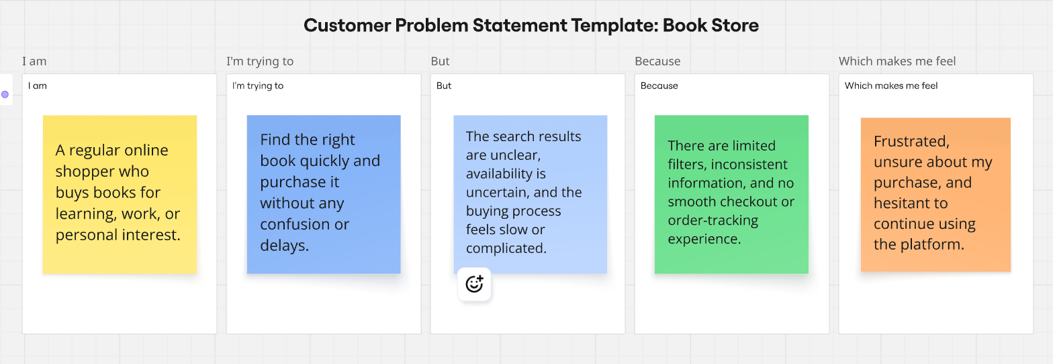
Reference: https://miro.com/templates/customer-problem-statement/

Problem Statement (PS) | I am (Customer) | I’m trying to | But | Because | Which makes me feel
PS-1 | a student preparing for exams | quickly find the right textbook/edition | search results are cluttered and irrelevant | there’s no proper filter for edition, author, or publication year | stressed and worried about getting the wrong book
PS-2 | a casual reader | buy books at affordable prices | the platform doesn’t show discounts or price comparisons clearly | pricing and offers are inconsistent or missing | unsure and discouraged from purchasing
PS-3 | a new customer | complete checkout smoothly | the checkout process is long and asks too many details | the form is not optimized for quick purchase | frustrated and close to abandoning the cart
PS-4 | a user who reads digitally | download an e-book immediately after purchase | there is no clear digital delivery workflow | the system handles physical and digital books the same way | confused and disappointed
PS-5 | a frequent online shopper | track my order easily | order status updates are unclear or missing | the platform doesn’t provide proper order history or tracking UI | anxious and dissatisfied.
PS-6 | An admin/  store owner | manage inventory and book listings efficiently | adding or editing books takes too many steps | the admin tools are not streamlined | slowed down and overwhelmed

